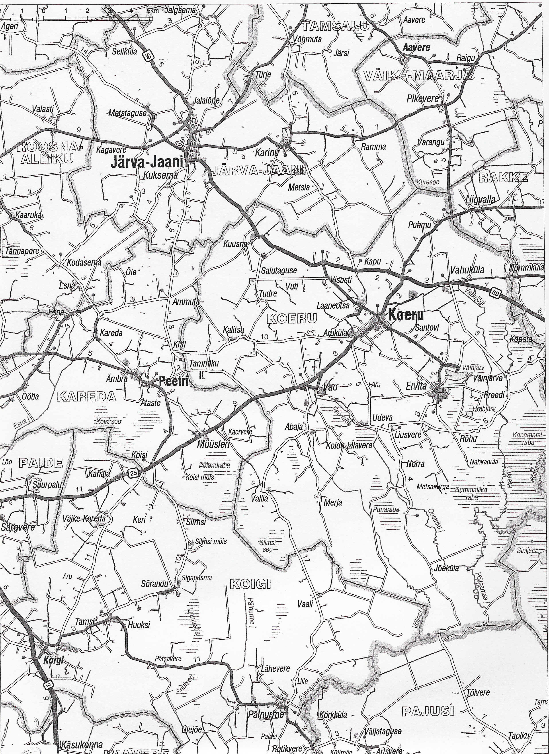
LK 4, 8 FINIS
LK 1, 5, 9 START
LK 2, 6 FINIS
LK 2, 6 START
RALLI START SERVICE
PARK
LK 1, 5, 9 FINIS
LK 3, 7 START
LK 10 FINIS
LK 10 START
LK 3, 7 FINIS
LK 4, 8 START
RALLI FINIS

