Organizer note:
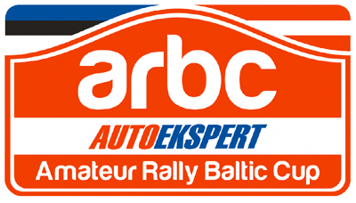
AUTOEKSPERT AMATEUR RALLY BALTIC CUP 2013

REGISTRATION FORM

THE APPLICANT

1st pilot

Name (given names)

Surname

Citizenship

Date of birth

Personal code (ID number)

Address

Tel

E-mail

2nd pilot (co-driver)

Name (given names)

Surname

Citizenship

Date of birth

Personal code (ID number)

Address

Tel

E-mail

RACING CAR

Make, model

Year of manufactured

Engine capacity

Registration No

Owner

GROUP

The competition is open for M1 and N1 category vehicles:

[_] group 1: 4WD (4WD road cars)

[_] group 2: 2WD (2WD road cars )

[_] group 3: SU (2WD road rear wheel drive cars produced in Soviet Union)

Competitor (pilot + co-diver) registration fee 100 EUR. Competitor must pay registration fee only once before his first event. Autoekspert Amateur Rally Baltic Cup participation fee shall not exempt the event of entry fee payment.

We confirm that we have read and understood the Amateur Rally Baltic Cup 2013 general regulations. We declare that we have examined this registration form and that the information given is true, correct and complete.

SIGNED BY (SIGNATURE)

…… (PRINT NAME OF THE PERSON SIGNING)

Registration form to the Autoekspert Amateur Rally Baltic Cup must be send to organizer according to supplementary regulations only once before crew will take part of first ARBC event.

Thank you to return this form, duly completed and signed, not later than 3 days before your first event, to the following e-mail address: info@rally.ee

