LADA classic CUP 2015 REGULATIONS

1 | Name of the series:

Lada Classic Cup 2015

2 | Regulations

This Cup is organized according to these regulations and supplementary regulations of the all included events. Supplementary regulations for each event are to be decided by the event Organizer.

3 | Events

Lada Classic Cup 2015 consists following rallies in the calendar below:

Date | Rally | Organizer | City
30-31 January | Halls Winter Rally | UAB Pitlane  www.hallswinterrally.lt | Utena
12-13 June | Rally Utena | ASK MGEAR  www.mgear.lt | Utena
11-12 September | Rally Kaunas | Vsi Capkausko autosportas | Kaunas

4 | Eligible Competitors

The Cup is open for all drivers with valid national and international license owners from ASN’s.

5 | Eligible Cars

The Cup is open for cars according to the Lada Classic Cup technical regulations, Appendix 1.

6 | Entries

All separate entries to the Lada Classic Cup must be sent to organizers according to supplementary regulations.
All drivers may take part Lada Classic Cup classification, presented Entry Form and Entry fee payment, holding valid driving “D” category license (except younger 18 years old) and the competitor’s license issued by LASF or other parental ASN valid in this event.
In every Lada Classic Cup event an entry fee of the crew, indicated in supplementary regulations of Rally competition of Cup event, paid to organiser in time, cannot be higher than 250-EUR with VAT.

7 | Results in the individual events

Separate results will be made up, dividing the finishers in the Lada Classc Cup group:
Points scale for the group in individual events is:

8 | Overall results

For overall result, all drivers could count their results from three events. If two or more drivers have equal points (including zero), their positions are fixed according to the quality of their finishes. Under this system one first place is better than any number of second places, one second place is better than any number of third places, if this still does not split the result, than driver who was started in more events. If this still does not split the result, the driver who have higher place in first event, than second, than third. If crew will be excluded on some of events, exclusion counts for overall result.
If superrally is provided in the events, superrally results will be counted for crew’s overall results also.

9 | Prize giving ceremony and prizes

At the end of the event winners of I-III places, will be awarded as well as cups and prizes if they are established by the Organiser. Events are open for extra prizes.
Best three crews of group in the LADA Classic Cup overall will be awarded with the medals, cups and diplomas if more than 8 crews are participated in the group on season.
Prize giving ceremony will take place in Rally Kaunas together with LARČ VI event prize giving ceremony.

10 | Protests and appeals

A claimant or his/her representative has a right to submit a protest. The submission order of the protests is regulated by LASC.
A protest must be filed together with the deposit of 145-EUR. It is returned if protest is upheld.
Stewards of the meeting on each event will solve all protests about rally. Lithuanian Automobile Sport Federation will solve all protests against Cup results or appeals for Stewards decisions.

11 | Lada Classic Cup organizer’s details:

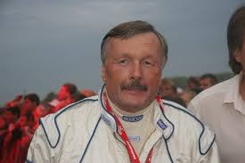
Honorary President of the Lithuanian Automobile Club
Undertake of Lada Classic Cup project
Stasys Brundza
E.mail: stasys.brundza@gmail.com

Responsible for organize Lada Classic Cup and contacts with drivers
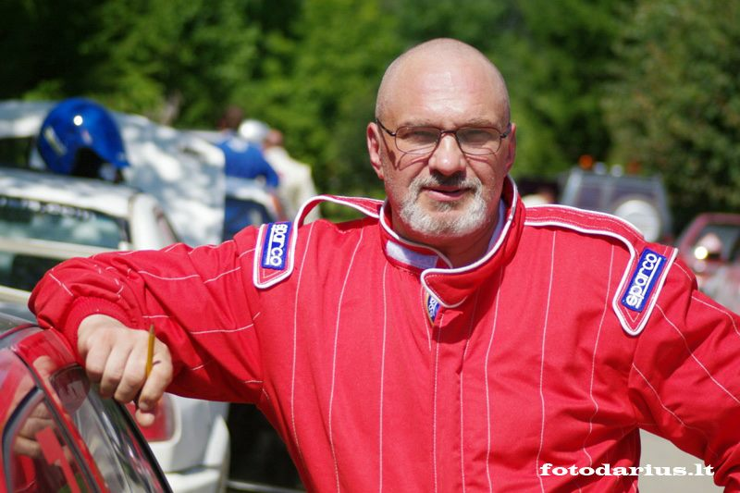
Dzintars Kaulakalns
E.mail: dzintars@300lakesrally.lt
Тel: 00371 26895990 (Latvia)
Тel: 0044 7743 747 200(England)

Responsible for results

Lada Classic Cup Secretary:
Audrius Beresnevicius
E.mail: audrius.beresnevicius@gmail.com
Тel:-00370 620 72 451(Lithuania)

11 | Approved, confirmed

Approved: LASF Rally Committee, 2014.12.12, Protocol No 2014-12

Prepared and confirmed: LASF General Secretary Rasa Jakienė, 2014.12.12

Official information www.lasf.lt

